A.R.M. Loxahatchee National Wildlife Refuge

Simple Refuge Screening Model (v. 4.0)
User’s Manual

Ehab A. Meselhe
Michael G. Waldon
William B. Roth

Prepared for the U.S. Fish and Wildlife Service under a cooperative-agreement with the University of Louisiana-Lafayette

Report #LOXA009-002
April 2009
A.R.M. Loxahatchee National Wildlife Refuge Simple Refuge Screening Model Version 4.00 Report #LOXA009-002

User’s Manual

Ehab Meselhe, Mike Waldon, William Roth¹

- Introduction

As restoration of the Arthur R. Marshall Loxahatchee National Wildlife Refuge (Refuge) continues, there is a need for a simple, quantitative methodology for predicting impacts of proposed management changes on Refuge stage. The Simple Refuge Screening Model (SRSM) simulates the water budget, regulation schedule implementation, and constituent dynamics for chloride (Cl), sulfate (SO4), and total phosphorus (TP). This document presents the model in a format that provides users with an understanding of both the theory and implementation of the SRSM. The objective is to give users the ability to accurately simulate various water need scenarios for the Refuge in order to gain a better understanding of this wetlands system and its dynamics. This manual assumes that the reader is generally familiar with the location Refuge hydrologic features, and with water quality issues relevant to the Refuge. For more information, users are directed to the Refuge Comprehensive Conservation Plan (USFWS 2000).

This manual describes version 4.00 of the SRSM. SRSM version 1 was implemented by Jeanne Arceneaux and others (Arceneaux, 2007; Arceneaux et al., 2007; Meselhe et al., 2007) as a daily water budget using Microsoft Excel; the results from this model were then used to drive the constituent model. The constituents were modeled by WASP, a program developed by the United States Environmental Protection Agency. Although there were advantages in using a commonly available spreadsheet program paired with a proven, robust constituent modeling tool, there were also some clear disadvantages. The version 1 implementation was complex and did not easily lend itself to modification. The workbook file was large, and its size grew as more days were simulated. Additionally, the limitation of using a one-day step size required ad-hoc procedures to avoid instability of the solution. Finally, the constituent models in WASP are limited to those provided in the closed-source executable from the USEPA. These factors and a desire to have a single, consistent model platform led to porting the stage and water quality models to the STELLA (http://www.iseesystems.com/index.aspx) simulation platform (version 2). Version 3 of the models ported the earlier version programs to the Berkeley Madonna (http://www.berkeleymadonna.com/index.html) simulation platform. In versions 2 and 3, stage and constituent models were separate. In version 4, models for stage and constituent concentration were combined into a single Madonna program. Use of the Berkeley Madonna commercial numerical differential equation solver package allows greater clarity in coding, supports shorter time steps obviating the need for the ad-hoc procedures of version 1, and provides a well documented user interface.

  - General Description of Model Structure

To calculate water volume the SRSM version 4.00 divides the Refuge into two compartments (also termed boxes or cells), Canal and Marsh, with assumed constant areas of 4.03 million m² and 560.02 million m², respectively. The rate of change of compartment volumes are calculated using the following differential equation which is based on the water budget for each compartment:

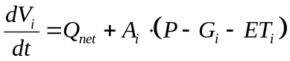

where:

i = denotes compartment (marsh or canal),
V_{i} = the compartmental volume (m³),
t = time (days),
Q_{net} = total flow into a compartment (m³/day),
A_{i} = compartment surface area (m²),
P = precipitation (m/day),
G_{i} = loss due to groundwater seepage (m/day), and
ET_{i} = loss due to evapotranspiration (m/day).

SRSM version 4.00 simulates the mass and concentration of chloride (Cl), total phosphorus (TP), and sulfate (SO4). Note that TP mass is measured as phosphorus, not phosphate, and SO4 mass is measured as sulfate, not sulfur. The compartmental design for these calculations differs from the water balance simulation. Here, a concentric arrangement of 4 compartments is used to represent the Refuge. Compartments 1-3 disaggregate the water-budget marsh compartment; compartment 4 represents the canal. Exchange flow is calculated in the marsh based on compartment surface area ratios. Calculation of flow between marsh cells 1-2 and 2-3 is made using a flat-pool assumption, and is analogous to a tidal prism flow calculation.

All constituents are simulated based on a mass balance equation. The loading terms of the mass budget (qnet, gload, and aload) are similar in all three constituents. However, the reactive load term (rload) is uniquely structured for each constituent. Chloride is modeled as a conservative constituent with zero reactive load. Its mass is lost or gained solely through the transport of water into or out of the system; therefore, the rload term in the following equation should be ignored when chloride is considered. Total Phosphorus (TP) dynamics are approximated with equations adapted from those presented in the Dynamic Model for Stormwater Treatment Areas (DMSTA) developed by Walker and Kadlec. Finally, sulfate (SO4) dynamics are simulated using a Monod relationship. Thus, a general equation for the rate of change of constituent mass in a compartment is given by:

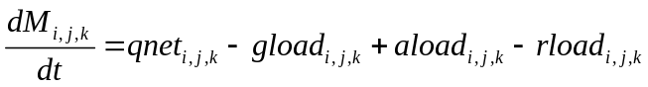

where:

i = constituent,
j = compartment number (1-4),
k = DMSTA calibration set (Phosphorus only),
M = mass (g),
t = time (days),
qnet = net mass flow in surface water (g/day),
gload = loss to groundwater seepage and evapotranspiration (g/day),
aload = gain from wet and dry deposition (g/day), and
rload = loss to storage uptake/release (TP) or reaction (SO4) (g/day).

Detailed descriptions of the above equations can be found in the companion model manuscript (Waldon et al., 2009).

  - Model Platform – Berkeley Madonna

The SRSM version 4.00 is implemented using the differential equations solver Berkeley Madonna version 8.3.9 (Madonna), which is a proprietary software developed by Robert I. Macey and George F. Oster. This program is the backdrop for the code of the SRSM, and while Madonna has some built-in functions, all SRSM components and processes are user-defined in the Equations window; the optional Madonna Flowchart window was not used in SRSM development (in terms used in Madonna documentation, SRSM is a “plain-text” rather than a “visual” model). Figure 1 shows the general format of the Madonna desktop. These windows may be resized or closed by the user. Each of these windows is discussed later in this document.

Madonna also has the capability to perform optimizations, curve-fitting, and sensitivity analyses. For a comprehensive description of all pre-programmed functions, users of the SRSM are encouraged to download the Madonna user’s guide from www.berkeleymadonna.com. Additionally, users may download a demo version of this software from the Berkeley Madonna web site and run this version of the SRSM version 4.00. However, while the demo version of the Madonna program allows users to modify and run models, the demo version does not allow the user to save model files or output of any kind.

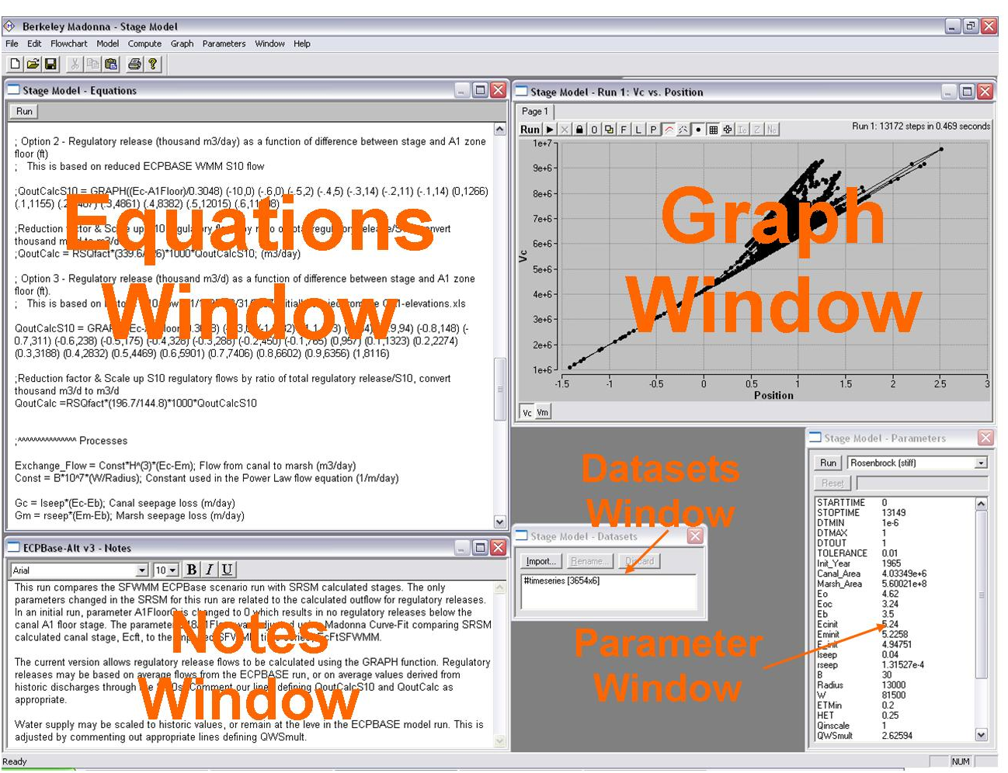

Figure 1 – Madonna model desktop

  - User’s Manual Objectives

This manual presents the pertinent information required for users to understand the components of SRSM (i.e., imported data, SRSM equation format, and post-processing methods). Ultimately, users should use this document as a companion for the model to assure accurate execution and interpretation.

  - Caveats

    - If unfamiliar with Berkeley Madonna, SRSM users are strongly urged to consult the user’s guide before attempting to run or manipulate any of the model components.

    - All parameter values represent those used to accurately validate and calibrate this model; discretion should be used when altering these values.

    - This model is set up to simulate a 13-year (1995-2007) period. All time series data needed to successfully run the model are stored within the model file. This manual provides the user with the background and understanding needed to revise this model simulation for other user-selected time periods or scenarios. Should the user want to simulate another time period or alternative conditions, the proper data must be obtained, properly formatted, and imported into the model.

    - Because of the level of spatial aggregation in the SRSM, the SRSM is not appropriate for applications that involve site-specific events. All results should be considered as spatial average values for the area of study.

    - This document offers a brief summary of model theory and equations. Users should consult the referenced documentation, the model code, and the companion manuscript for more in-depth descriptions of equations and calibration parameter values.

- Data Preparation

This section describes how to import the necessary time series text files. The 7 separate data input files are outlined in Table 1.

Filename (alphabetical) | Data Vectors | Summary
CL.txt | 14 | Chloride concentration values (mg/L)
INFLOW.txt | 20 | Historic inflow values (m3/d)
OUTFLOW.txt | 20 | Historic outflow values (m3/d)
PET.txt | 3 | Precipitation and Evapotranspiration (m/d)
Regulation.txt | 5 | Water supply release from S-39 and hurricane releases from S-10 structures (m3/d)
SO4.txt | 14 | Sulfate concentration values (mg/L)
TP.txt | 14 | TP concentration values (mg/L)

Table 1 – SRSM input files

Users may create data files for import in any spreadsheet editing program. Madonna imports data files in either tab-delimited text format or comma-separated values (CSV) format. The preloaded input files in the SRSM are primarily derived from data downloaded from the South Florida Water Management District’s database (DBHYDRO). Although these data are readily available, and methods of preparation documented (Arceneaux, 2007; Meselhe et al., 2005), it is strongly suggested that the user first run model simulations with the preloaded datasets.

  - Spreadsheet Formatting

The Berkeley Madonna software imports time series data from a 2-dimensional array dataset. The first column of the array is the time value in days of the simulation beginning with zero and increasing monotonically to the final simulation day (in this case, 0 to 4747). Madonna applies linear interpolation between data values. In order to avoid interpolation in the time series data, the user is encouraged to format the time series such that there are two values (the same value) for each time period (e.g., t_{1.000} = 5.656 and t_{1.999} = 5.656); thus, the imported data become similar to a step function. To minimize the effort, a data organization subroutine may be written into a Visual Basic for Applications (VBA) module in Microsoft Excel. Additionally, the user must note that text and other non-numerical symbols will not be imported into Madonna; in fact, the importing process will cease if Madonna encounters such a symbol. As a reference, an abbreviated example spreadsheet, along with its VBA data organization subroutine, is provided in the Appendix of this document.

  - Importing Data

Once a dataset has been created, it may be imported into Madonna by choosing Import Dataset from the File menu. The user is then prompted to specify the dataset type and filename; in this case all datasets are entered as 2D and given a specified filename per Table 1 (the file extension should not be included). Madonna syntax requires that the name of the input file be preceded by a pound sign (#). Typically, for 2-dimensional datasets a timing variable must be given; this variable tells Madonna at which times to read imported data. A simple solution is to use the build in function named TIME. In Madonna the syntax TIME represents a linear function that counts from the specified start time (STARTTIME) value to the specified stop time (STOPTIME) value based upon the time step (DT). The following equations set variables for precipitation (P) and evapotranspiration (ET) to the appropriate imported time series data values:

P = #PET(day,1); (m/day)
ET = #PET(day,2); (m/day)

where #PET indicates the file of imported data being used, day is the integer day of the simulation, and the numerical value indicates a column in the imported dataset. Once data are successfully imported, the file name will appear in the Datasets window on the Madonna desktop. Additionally, it is important to note that imported data are saved directly in the Madonna model file (*.mmd). There is no dynamic link between these data and the parent spreadsheet; therefore, any changes to the time series data must be made in the parent *.csv or *.txt file and then re-imported into the Madonna model.

- Comments, Constant Values, Arrays, & Equations

Comments within the equation window provide model self-documentation, and are an important part of the SRSM documentation. There are two alternative syntaxes for comments in Madonna. Any text between left and right curly brackets, { }, is treated as a comment and not processed. This form of comment can span multiple lines of text. On a single line, all text following a semi-colon is also treated as a comment.

Additionally, in imported text data files, all characters on a line following the first non-numeric character are ignored. This allows comments identifying source or column names to be included within these files.

Equation syntax in Berkeley Madonna is similar to that in other programming languages such as Basic or FORTRAN. The value calculated on the right-hand-side of an equals sign is assigned to the variable on the left-hand-side. Unlike common programming languages, but similar to spreadsheets, Berkeley Madonna is non-procedural; meaning the ordering of the equations is not significant. Berkeley Madonna effectively sorts the equations in order to calculate the value of variables before they are used in subsequent calculations; the program recognizes circular references if such a sorting can not be accomplished (Macey et al., 2000).

Many of the SRSM equations have been consolidated by using arrays. Such equations are set up by using the square brackets ([]) for the values to be arrayed. There are 3 sets of arrayed variables: constituents, compartment, and DMSTA calibration sets. For all equations displayed in sections labeled 3.4.(3-8) the user can see examples of arrayed initial conditions and differential equations. Labels for each of the arrayed variables are given below.

Arrays are used extensively in SRSM to express equations that are repeated for a range of cells or constituents. Many of the array index values have been programmed as constants to enhance clarity of the code. For example, the equation “tp=3” defines a constant named tp that can be used as an array index (subscript) in place of simply the more obscure number 3. Madonna does identify constants during compilation, and there is apparently no runtime cost associated with this programming style.

;DEFINE ARRAYS

;REFUGE GEOMETRY
ncell=4; total number of cells, canal is cell ncell
nm=ncell-1; number of marsh cells
canal=ncell; cell number for canal (there is only 1 canal cell in version 4.00)

;CONSTITUENTS
nconstit= 3
cl= 1; chloride; conservative
so4=2; sulfate; monod relationship;
tp= 3; tp modeled with DMSTA equations

;DMSTA CALIBRATION SETS
emerg = 1; Emergent marsh
pew = 2; Pre-existing wetland

Madonna has a unique notation for array operations (Macey et al., 2000). Equations imply looping through a range of subscripts through ranges specified on the left-hand-side of the equation (see for examples sections 3.4.5 and 3.4.6 below). The variables i, j, and k are reserved in Madonna to refer on the right-hand-side of the equation to the first, second, and third array index, respectively, of the variable on the left. This notation replaces loops that are more commonly used in other programming languages.

  - Runtime Options

Madonna offers several numerical methods to solve ODEs. The SRSM may be executed accurately and expeditiously using the RK4 (fourth order Runge-Kutta) method.

The current SRSM is set up to simulate the 13 year period from 1995 to 2007. The user may specify the simulation period with the STARTTIME and STOPTIME functions. Model coding for the runtime parameters is given below.

    - Code

METHOD RK4
STARTTIME = 0 {JAN95}; 3287 {JAN04}; 1826 {JAN00};
STOPTIME= 4747 {DEC07}; 3652 {DEC04}; 4382 {DEC06};
DT = 0.005
DTOUT = 1

By default, Madonna saves model output every calculation time step, which can become costly as model size and complexity increases. The built-in variable DTOUT defines the time period that elapses between data storage for a simulation run. Setting DTOUT can reduce memory requirements. Here, SRSM output is stored every one time unit (i.e., one day). If the user desires to store all output data, then DTOUT should be set equal to zero or, alternatively, the DTOUT statement can be removed.

  - Parameters

These values fall into two categories for the SRSM code – simulation option parameters, and model parameters. The simulation option parameters are given at the beginning of the model code (found in the Equations window). These allow some flexibility with model calculations, input data, and initial conditions. The user can choose outflow type, scale flow and constituent load, choose time series or constant values for boundary concentration, and choose different initial condition sets. The remaining parameters are calibrated and calculated values needed for an accurate base simulation of the SRSM.

All model parameters (constant values) that are not arrayed can also be viewed in the Parameters window, which allows the user to change values and reset them without directly changing the code. Parameters with values modified from those set in the Equations window are flagged by an asterisk in the Parameters window. Users are cautioned that if parameter values are changed using the Parameter window, the altered values may persist in future model runs until they are reset. Additionally, the Overlay Plots (Figure 3) button can be used to display multiple model runs on the same graph; this feature is very helpful when visually assessing parameter alterations. Lists of all parameters are given in the appendix of this document.

  - Processes

Model processes are those equations that contribute to state variable calculation (e.g. groundwater seepage, corrected evapotranspiration, and reaction losses). Such equations represent values that can change with each time step. The user should consult the referenced material for more in depth discussions and explanations of model processes.

  - State Variables

Berkely Madonna has several ways to code state variables. The SRSM uses the d/dt() option to define differential equations. All SRSM differential equations are given below. It is necessary to specify an initial value for all state variables using the INIT initializer syntax.

This version of the SRSM directly calculates the change in volume of the Canal and Marsh compartments as per the 2-compartment structure described by Arceneaux et al. (2007). The stage is then calculated from the volume. It must be noted that the area of the compartments is constant (i.e., it does not change with stage). The calculated value for the exchange flow (canal to marsh flow) is used to drive the volume differential equations for the 4-compartment constituent model.

    - Initial Volume Values: 2-compartment Model

INIT vol_canal = (Ecinit - Eoc) * Canal_Area; Initial Canal Volume (m3)
INIT vol_marsh = (Eminit - Eo) * Marsh_Area; Initial Marsh Volume (m3)

    - Volume Differential Equations: 2-compartment Model

d/dt(vol_canal) = NetInFlow - Exchange_Flow +((P- Gc - ETc)*Canal_Area)
d/dt(vol_marsh) = Exchange_Flow +((P - Gm - ETm)*Marsh_Area)

    - Initial Volume Values: 4-compartment Model

INIT vol[1..nm] = (Eminit - Eo) * area[i]
INIT vol[canal] = (Ecinit - Eoc) * area[canal]

    - Volume Differential Equations: 4-compartment Model

d/dt(vol[canal])= Qin - Qout - Exchange_Flow + ((P-ETc-Gc)*area[canal])
d/dt(vol[1..nm])= ((P-ETm-Gm)*area[i]) + (Exchange_Flow*qmcfactor[i])

In addition to volume state variables the SRSM calculates storage and constituent mass similarly.

    - Initial Mass Values: Chloride Only

INIT mass[cl,1,emerg..pew]= D_M0*area[1]* INIT_Conc[i,j,k]
INIT mass[cl,2,emerg..pew]= D_M0*area[2]* INIT_Conc[i,j,k]
INIT mass[cl,3,emerg..pew]= D_M0*area[3]* INIT_Conc[i,j,k]
INIT mass[cl,canal,emerg..pew]= D_C0*area[canal]* INIT_Conc[i,j,k]

    - Mass Differential Equations

{COMPARTMENT 1} d/dt(mass[1..nconstit, 1,emerg..pew]) = qload[i, 1,k] - qload[i, 2,k] + aload[i, 1] - gload[i, 1,k] + rload[i, 1,k]
{COMPARTMENT 2} d/dt(mass[1..nconstit, 2,emerg..pew]) = qload[i, 2,k] - qload[i, 3,k] + aload[i, 2] - gload[i, 2,k] + rload[i, 2,k]
{COMPARTMENT 3} d/dt(mass[1..nconstit, 3,emerg..pew]) = qload[i, 3,k] + aload[i, 3] - gload[i, 3,k] + rload[i, 3,k]
{COMPARTMENT 4} d/dt(mass[1..nconstit, canal,emerg..pew]) = sload[i,j,k] - qload[i, 1,k] + aload[i, canal] - gload[i, canal,k] + rload[i, canal,k]

    - Initial Storage Values

INIT dmsta_store[tp, 1..nm, emerg..pew]= init_storage[i,j,k] ; g/m2

    - Storage Differential Equations

d/dt(dmsta_store[tp, 1..nm, emerg..pew])= upPrM2[i, j,k] - ((Release[i, j,k] + Burial[i, j,k])/area[j])

  - Volume-Stage Relationship

SRSM version 4.00 is structured to incorporate a storage-stage relationship for both the marsh and canal compartments. To maintain consistency with the earlier model version, a constant surface area is currently assumed for each compartment resulting in a linear relationship between storage volume and stage. Canal (Ec) and marsh (Em) stage values in meters are calculated using the GRAPH capability of Madonna. Future versions of the SRSM could include a more detailed volume-stage relationship. However, performance of the model is good without the addition of this complexity.

;Stage (m) NGVD 29 is currently calculated using constant area

; ( Vc(m3), Ec(m)) Area Canal = 4033485.467 (m2)
Ec = GRAPH (Vc) (-13068492.91,0) (0, 3.24 {Canal bottom elevation}) (27266361.76, 10)

; ( Vm(m3), Em(m)) Area Marsh = 560021212.8 (m2)
Em = GRAPH (Vm) (-2587298003, 0) (0, 4.62 {Marsh bottom elevation}) (3012914125, 10)

- Regulation Schedule

This document assumes that SRSM users are familiar with this WCA-1 Regulation Schedule (USACE 1994), as its specifics are not included here. A description of the Regulation Schedule is available in the Arthur R. Marshall Loxahatchee National Wildlife Refuge Comprehensive Conservation Plan (USFWS 2000). The following sub-sections present the Regulation Schedule model code which appears in the Madonna Equations window.

The variables A1FloorFeet and BFloorFeet are the stage in feet (NGVD) of the bottom of the A1 and B Regulation Schedule zones, respectively. For consistency with the SRSM, these variables are converted to meters.

A1FloorFeet = GRAPH(DayofYear) (0,17.2) (132, 15.75) (188, 15.75) (267, 17.5) (334, 17.5) (366, 17.2); Floor of A1 Zone (ft)
BFloorFeet = 14; Floor of B Zone (ft)

A1Floor = A1FloorFeet*0.3048; A1 Floor (m)
BFloor = BFloorFeet*0.3048; B Floor (m)

  - SRSM Regulatory Release

A regulatory release is a discharge of water out of the Refuge that occurs as a result of the Refuge stage in relation to the Regulation Schedule. Magnitude of outflow during a regulatory release is not specified within the Regulation Schedule. It is therefore necessary to make assumptions related to water management in order to model regulatory releases. The prior version of the SRSM modeled regulatory releases based on historic discharges.

  - Regulatory Release Calculations

This section describes calculations used in the Regulation Schedule. Outflow is calculated when the CalcQRo value (in the simulation option parameters section) is set to a value of 1; conversely, a value of 0 uses historical outflow in the model simulation. The calculated outflow only represents regulatory releases from certain structures (S10ACDE and S39); therefore, historic outflows from other structures in the Refuge must be imported to supplement the calculated outflow.

Qout = IF (CalcQRo = 0) THEN (QoutHistoric) ELSE (QoutCalc + QWaterSupply + Qout_HistStruct + Qout_hurricane)

Qout_HistStruct = G94A_out + G94B_out + G94C_out + G300_out + S5AS_out + G301_out + G338_out; Structures in the north and east involved with water supply

; Regulatory release (thousand m3/d) as a function of difference between stage and A1 zone floor (ft).
; This is based on historic S10 flow 1/1/1995 - 8/31/2007 initially copied from file CA1-elevations.xls

QoutCalcS10 = GRAPH((Ec-A1Floor)/0.3048) (-1.3,0) (-1.2,32) (-1.1,113) (-1,64) (-0.9,94) (-0.8,148) (-0.7,311) (-0.6,238) (-0.5,175) (-0.4,328) (-0.3,288) (-0.2,450) (-0.1,765) (0,957) (0.1,1323) (0.2,2274) (0.3,3188) (0.4,2832) (0.5,4469) (0.6,5901) (0.7,7406) (0.8,6602) (0.9,6356) (1,8116)

;Reduction factor & Scale up S10 regulatory flows by ratio of total regulatory release/S10, convert thousand m3/d to m3/d
QoutCalc =RSQfact*(196.7/144.8)*1000*QoutCalcS10

The ratio 196.7/144.8 is the historic average annual total Refuge regulatory release volume divided by the average annual S-10 volume.

- Model Execution & Post-processing

Berkeley Madonna’s user interface for model execution and post-processing is very simple; in fact, they can both be operated from a single location. All operations needed for a general simulation run can be performed in the Graph window. The provided image designates the pertinent buttons with which the user should be familiar; however, for explicit explanations on each button, the Berkeley Madonna user’s guide (Macey et al., 2000) should be consulted. The model may be executed from the Graph window by pressing the Run button; otherwise, the user may select Run from the Compute menu.

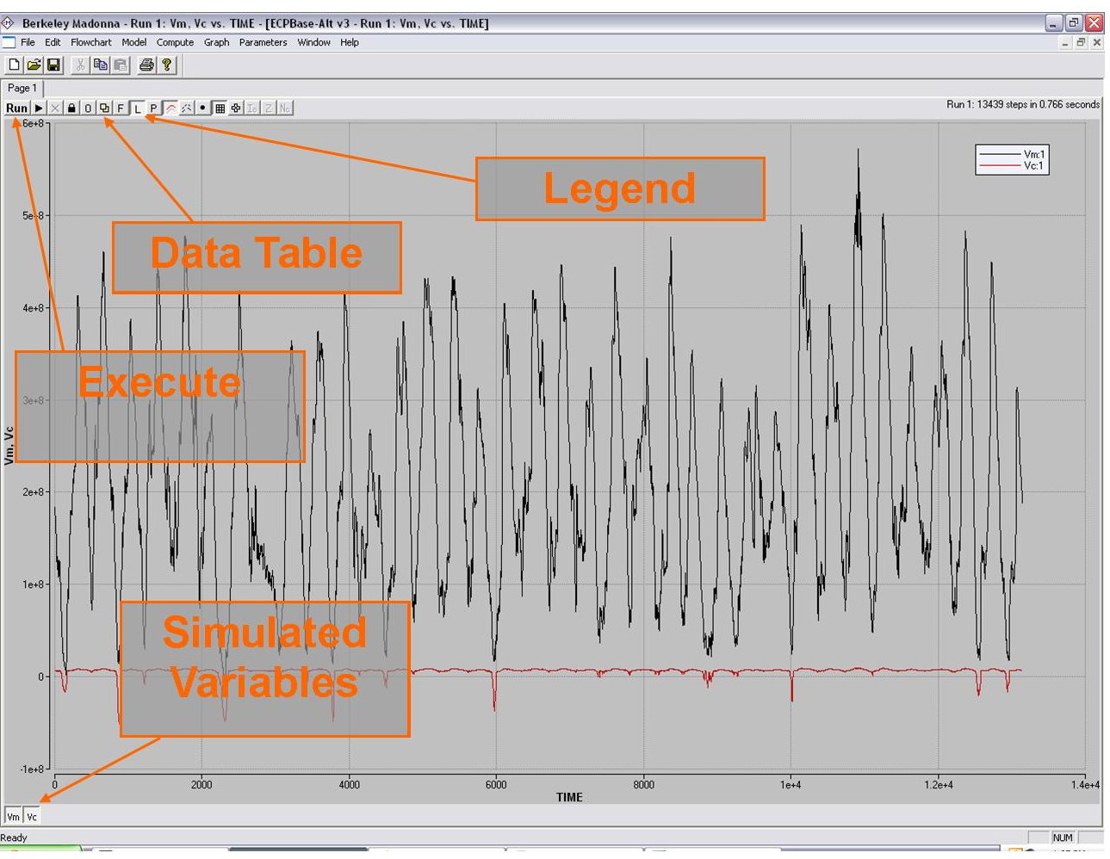

Figure 2 – Graphical Output

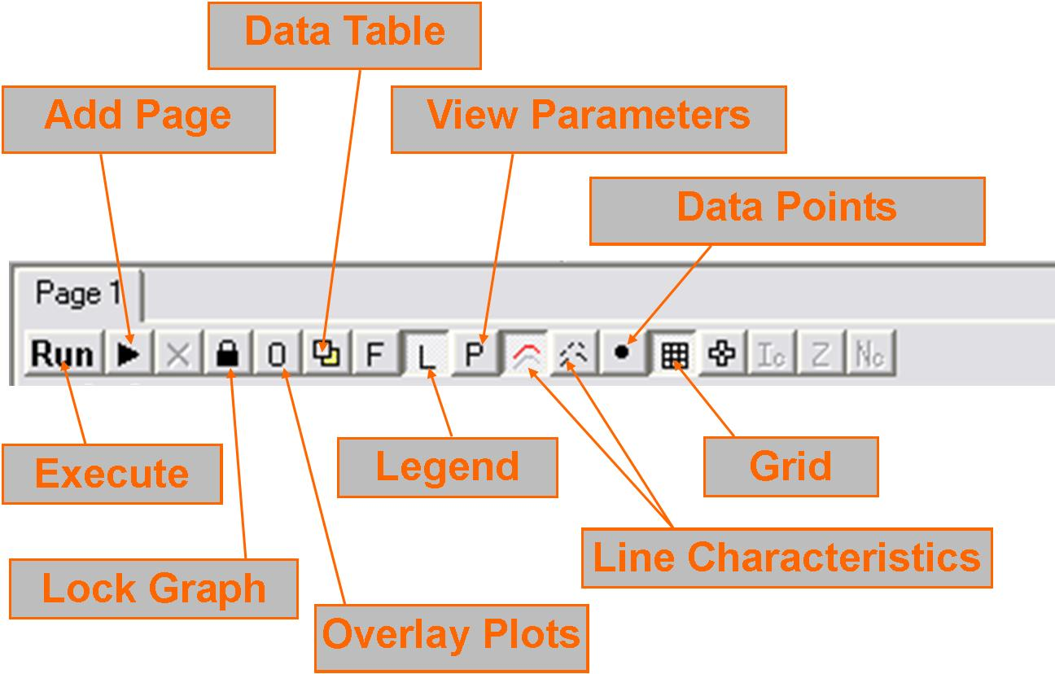

Figure 3 – Graph Toolbar

After pressing the Run button, Madonna will automatically output several variables from the model in the Graph window. To specify which variables to output, the user can double-click in the window and choose them from a list or select Choose Variables from the Graph menu. Once the desired variables are chosen and a model run is complete, the user may print the graph directly from Madonna or export the data as *.csv or *.txt. To export data the table must be displayed in the Graph window by clicking the Data Table button (see Figure 3). Then the user can select Export Table from the File menu, or use the Copy Table selection under the edit drop down menu.

For further information, users may contact the authors by email at:

Dr. Ehab Meselhe (meselhe@louisiana.edu),
Dr. Mike Waldon (mike@mwaldon.com), or
William Roth (wbr9736@louisiana.edu)

Citations

Arceneaux, J. (2007). “The Arthur R. Marshall Loxahatchee National Wildlife Refuge Water Budget and Water Quality Models,” MS. Thesis, University of Louisiana, Lafayette, LA.
Arceneaux, J., Meselhe, E. A., Griborio, A., and Waldon, M. G. (2007). “The Arthur R. Marshall Loxahatchee National Wildlife Refuge Water Budget and Water Quality Models.” Report No. LOXA-07-004, currently available at < http://loxmodel.mwaldon.com >, University of Louisiana at Lafayette in cooperation with the U.S. Fish and Wildlife Service, Lafayette, Louisiana.
Macey, R., Oster, G., and Zahnley, T. (2000). “Berkeley Madonna User’s Guide Version 8.0.” University of California, Department of Molecular and Cellular Biology, Berkeley, CA.
Meselhe, E., Arceneaux, J., and Waldon, M. G. (2007). “Mass Balance Model Version 1.01.” LOXA-07-002, currently available at < http://loxmodel.mwaldon.com >, University of Louisiana - Lafayette in cooperation with the U.S. Fish and Wildlife Service, Lafayette, LA.
Meselhe, E. A., Griborio, A. G., Gautam, S , Arceneaux, J.C., Chunfang, C.X., 2005. “Hydrodynamic And Water Quality Modeling For The A.R.M. Loxahatchee National Wildlife Refuge, Phase 1: Preparation Of Data, Task 1: Data Acquisition and Processing.” Report #LOXA05-014, University of Louisiana at Lafayette, prepared for the Arthur R. Marshall Loxahatchee National Wildlife Refuge, USFWS, Lafayette, LA. Available online: http://sofia.usgs.gov/lox_monitor_model/advisorypanel/data_acq_report.html.
USACE. (1994). "Environmental Assessment: Modification of the Regulation Schedule Water Conservation Area No. 1." available at < http://mwaldon.com/Loxahatchee/GrayLiterature/USACE-1995-Lox-Regulation-Schedule.pdf >, US Army Corps of Engineers, Jacksonville, FL.
USFWS. (2000). "Arthur R. Marshall Loxahatchee National Wildlife Refuge Comprehensive Conservation Plan." available at < http://loxahatchee.fws.gov >, U.S. Fish and Wildlife Service, Boynton Beach, Florida.
Waldon, M. G., Meselhe, E. A., Roth, W. B., Wang, H., Chen, C. (in prep). “A.R.M. Loxahatchee National Wildlife Refuge Water Quality Modeling – Rates, Constants, and Kinetic Formulations.” Report No. LOXA009-003, University of Louisiana at Lafayette in cooperation with the U.S. Fish and Wildlife Service, Lafayette, Louisiana.

Appendix

- Example Spreadsheet Format
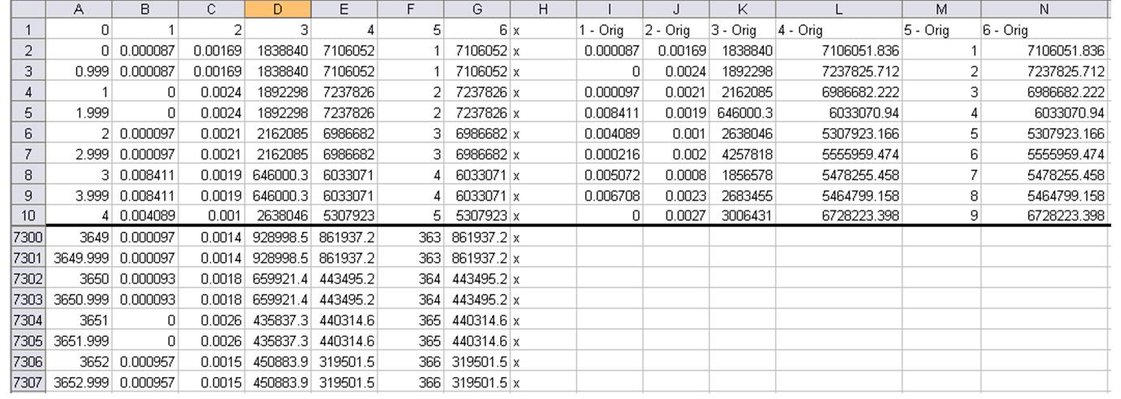

Figure 4 – Sample Excel Spreadsheet

- Data Formatting with VBA

Sub LoopRange1()

'have x & z start at row 2
'have y start at row 3

x = 2
z = 2
y = 3

‘loop until a blank row is found
‘for the purposes of this we need a column of 7306 (3653*2) values
‘in order to separate the input data appropriately.
‘note that this is set up for data to be read only in column 2 (date column)
‘and for the sorted data to be output in columns B, C, D, E, F and G.

Do While Cells(x, 1).Value <> ""

'This will put the values of the
'9th column (I) in the 2nd
'column (B) such that data
'abcd... become aabbccdd...

Cells(x, 2).Value = Cells(z, 9).Value
Cells(y, 2).Value = Cells(z, 9)

Cells(x, 3).Value = Cells(z, 10).Value
Cells(y, 3).Value = Cells(z, 10)

Cells(x, 4).Value = Cells(z, 11).Value
Cells(y, 4).Value = Cells(z, 11)

Cells(x, 5).Value = Cells(z, 12).Value
Cells(y, 5).Value = Cells(z, 12)

Cells(x, 6).Value = Cells(z, 13).Value
Cells(y, 6).Value = Cells(z, 13)

Cells(x, 7).Value = Cells(z, 14).Value
Cells(y, 7).Value = Cells(z, 14)

‘increse the value of x by 2 in order to create the spacing and increase the
‘value of z by 1 to read the data in the correct order (ie row by row).
‘Y increases by 2 to insert data in rows "skipped" by x+2 term.

x = x + 2
z = z + 1
y = y + 2

Loop

End Sub

- Imported Datasets

Provided below is a list of all imported datasets and their respective variable names used in the SRSM.

Variable Name | File | Column | Description
P | PET | 1 | Area average precipitation (m/day)
ET | PET | 2 | Observed evapotranspiration (m/day)
S39_out | OUTFLOW | 1 | Observed structure outflow (m3/day)
G94A_out | OUTFLOW | 2 | Observed structure outflow (m3/day)
G94B_out | OUTFLOW | 3 | Observed structure outflow (m3/day)
G94C_out | OUTFLOW | 4 | Observed structure outflow (m3/day)
G300_out | OUTFLOW | 8 | Observed structure outflow (m3/day)
S5AS_out | OUTFLOW | 9 | Observed structure outflow (m3/day)
G301_out | OUTFLOW | 11 | Observed structure outflow (m3/day)
G338_out | OUTFLOW | 15 | Observed structure outflow (m3/day)
S10E_out | OUTFLOW | 16 | Observed structure outflow (m3/day)
S10D_out | OUTFLOW | 17 | Observed structure outflow (m3/day)
S10C_out | OUTFLOW | 18 | Observed structure outflow (m3/day)
S10A_out | OUTFLOW | 19 | Observed structure outflow (m3/day)
G94A_in | INFLOW | 2 | Observed structure inflow (m3/day)
G94C_in | INFLOW | 4 | Observed structure inflow (m3/day)
G94D_in | INFLOW | 5 | Observed structure inflow (m3/day)
ACME1_in | INFLOW | 6 | Observed structure inflow (m3/day)
S362_in | INFLOW | 7 | Observed structure inflow (m3/day)
G300_in | INFLOW | 8 | Observed structure inflow (m3/day)
S5AS_in | INFLOW | 9 | Observed structure inflow (m3/day)
S5A_in | INFLOW | 10 | Observed structure inflow (m3/day)
G301_in | INFLOW | 11 | Observed structure inflow (m3/day)
G310_in | INFLOW | 12 | Observed structure inflow (m3/day)
G251_in | INFLOW | 13 | Observed structure inflow (m3/day)
S6_in | INFLOW | 14 | Observed structure inflow (m3/day)
G338_in | INFLOW | 15 | Observed structure inflow (m3/day)
S10A_hurricane | Regulation | 1 | Supplementary emergency water release (m3/day)
S10C_hurricane | Regulation | 2 | Supplementary emergency water release (m3/day)
S10D_hurricane | Regulation | 3 | Supplementary emergency water release (m3/day)
S39_WS | Regulation | 4 | Supplementary water supply release (m3/day)
G94A_TP | TP | 1 | Observed total phosphorus concentration (mg/L)
G94C_TP | TP | 2 | Observed total phosphorus concentration (mg/L)
G94D_TP | TP | 3 | Observed total phosphorus concentration (mg/L)
ACME1_TP | TP | 4 | Observed total phosphorus concentration (mg/L)
S362_TP | TP | 5 | Observed total phosphorus concentration (mg/L)
G300_TP | TP | 6 | Observed total phosphorus concentration (mg/L)
S5AS_TP | TP | 7 | Observed total phosphorus concentration (mg/L)
S5A_TP | TP | 8 | Observed total phosphorus concentration (mg/L)
G301_TP | TP | 9 | Observed total phosphorus concentration (mg/L)
G310_TP | TP | 10 | Observed total phosphorus concentration (mg/L)
G251_TP | TP | 11 | Observed total phosphorus concentration (mg/L)
S6_TP | TP | 12 | Observed total phosphorus concentration (mg/L)
G338_TP | TP | 13 | Observed total phosphorus concentration (mg/L)
G94A_Cl | CL | 1 | Observed chloride concentration (mg/L)
G94C_Cl | CL | 2 | Observed chloride concentration (mg/L)
G94D_Cl | CL | 3 | Observed chloride concentration (mg/L)
ACME1_Cl | CL | 4 | Observed chloride concentration (mg/L)
S362_Cl | CL | 5 | Observed chloride concentration (mg/L)
G300_Cl | CL | 6 | Observed chloride concentration (mg/L)
S5AS_Cl | CL | 7 | Observed chloride concentration (mg/L)
S5A_Cl | CL | 8 | Observed chloride concentration (mg/L)
G301_Cl | CL | 9 | Observed chloride concentration (mg/L)
G310_Cl | CL | 10 | Observed chloride concentration (mg/L)
G251_Cl | CL | 11 | Observed chloride concentration (mg/L)
S6_Cl | CL | 12 | Observed chloride concentration (mg/L)
G338_Cl | CL | 13 | Observed chloride concentration (mg/L)
G94A_SO4 | SO4 | 1 | Observed sulfate concentration (mg/L)
G94C_SO4 | SO4 | 2 | Observed sulfate concentration (mg/L)
G94D_SO4 | SO4 | 3 | Observed sulfate concentration (mg/L)
ACME1_SO4 | SO4 | 4 | Observed sulfate concentration (mg/L)
S362_SO4 | SO4 | 5 | Observed sulfate concentration (mg/L)
G300_SO4 | SO4 | 6 | Observed sulfate concentration (mg/L)
S5AS_SO4 | SO4 | 7 | Observed sulfate concentration (mg/L)
S5A_SO4 | SO4 | 8 | Observed sulfate concentration (mg/L)
G301_SO4 | SO4 | 9 | Observed sulfate concentration (mg/L)
G310_SO4 | SO4 | 10 | Observed sulfate concentration (mg/L)
G251_SO4 | SO4 | 11 | Observed sulfate concentration (mg/L)
S6_SO4 | SO4 | 12 | Observed sulfate concentration (mg/L)
G338_SO4 | SO4 | 13 | Observed sulfate concentration (mg/L)

- Simulation Option Parameters

Variable Name | Default Value | Explanation
CalcQRo | 1 | Distinguishes between calculated (1) or historic outflow (0)
Qinscale | 1 | Scaling factor for structure inflow
QWSmult | 1 | Scaling factor for water supply demand
RSQfact | 1 | Scaling factor for regulatory release
SCALE_TPLOAD | 1 | Scaling factor for total phosphorus load
SCALE_CLLOAD | 1 | Scaling factor for chloride load
SCALE_SO4LOAD | 1 | Scaling factor for sulfate load
constTPConc | 0 | Distinguishes between timeseries data (1) or constant value (0) for inflow TP concentration
constCLConc | 0 | Distinguishes between timeseries data (1) or constant value (0) for inflow CL concentration
constSO4Conc | 0 | Distinguishes between timeseries data (1) or constant value (0) for inflow SO4 concentration
constTP_CONC | 0.01 | Constant value for TP inflow
constCL_CONC | 80 | Constant value for CL inflow
constSO4_CONC | 30 | Constant value for SO4 inflow
SET | 1 | Distinguishes between initial condition sets for start date (1) 1995 (2) 2004 (3) 2000

- Model Parameters

Variable Name | Value | Description
Canal_Area | 4033485.468 | Canal surface area (m2)
Marsh_Area | 560021212.8 | Marsh surface area (m2)
Eo | 4.62 | Marsh bottom elevation (m)
Eoc | 3.24 | Canal bottom elevation (m)
Eb | 3.5 | Water stage outside Refuge (m)
lseep | 0.042 | Canal seepage constant (1/day)
rseep | 0.000349076 | Marsh seepage constant (1/day)
B | 30 | Transport coefficient (1/m-day)
Radius | 13000 | Average marsh radius (m)
W | 81500 | Average marsh width (m)
ETMin | 0.2 | ET reduction factor
HET | 0.25 | ET depth reduction boundary (m)
area[1] | 89359148.07 | Surface area of compartment 1 (m2)
area[2] | 224100185 | Surface area of compartment 2 (m2)
area[3] | 246561879.8 | Surface area of compartment 3 (m2)
area[canal] | 4033485.467 | Surface area of compartment 4 (m2)
evap | 0.65 | Fraction of ET that is evaporation
transp | 0.35 | Fraction of ET that is transpiration
WetDep[cl] | 2 | Chloride concentration in rainfall (mg/L)
DD[cl] | 1136 | Chloride dry deposition (mg/m2-yr)
WetDep[so4eco] | 1 | Sulfate concentration in rainfall (mg/L)
DD[so4eco] | 138.2 | Sulfate dry deposition (mg/m2-yr)
WetDep[dmsta_constit] | 0.01 | Phosphorus concentration in rainfall (mg/L)
DD[dmsta_constit] | 10 | Phosphorus dry deposition (mg/m2-yr)
khalfSO4 | 1 | Sulfate half saturation constant (g/m3)
MaxSO4Removal | 14.4 | Maximum sulfate removal (g/m2-yr)
benthic | 0 | Internal loading rate for the canal (g/m2-day)
K1[emerg] | 0.1064 | Phosphorus (Emergent Wetland) maximum uptake rate (m3/mg-yr)
K1[pew] | 0.221 | Phosphorus (Pre-existing Wetland) maximum uptake rate (m3/mg-yr)
K2[emerg] | 0.002 | Phosphorus (Emergent Wetland) recycle rate (m2/mg-yr)
K2[pew] | 0.0042 | Phosphorus (Pre-existing Wetland) recycle rate (m2/mg-yr)
K3[emerg] | 0.3192 | Phosphorus (Emergent Wetland) burial rate (1/yr)
K3[pew] | 0.6631 | Phosphorus (Pre-existing Wetland) burial rate (1/yr)
mindepth | 0.05 | Minimum water depth (m)

Center for Louisiana Water Studies, University of Louisiana at Lafayette
A.R.M Loxahatchee National Wildlife Refuge, U.S. Fish and Wildlife Service
http://wwwalker.net/dmsta/index.htm
Available for download at: http://loxmodel.mwaldon.com/
http://www.sfwmd.gov/portal/page?_pageid=2894,19708232&_dad=portal&_schema=PORTAL

